Joshua Okero LAB 1

1.

Create a bar plot of the profit for each sub-category of product. (Hint: use the arrow next to "Product" to find the Sub-Categories.) Title the plot "Profit by product sub-category, JL" but fill in your own initials instead of JL. Sort the plot so that the viewer can easily see the most and least profitable sub-categories.

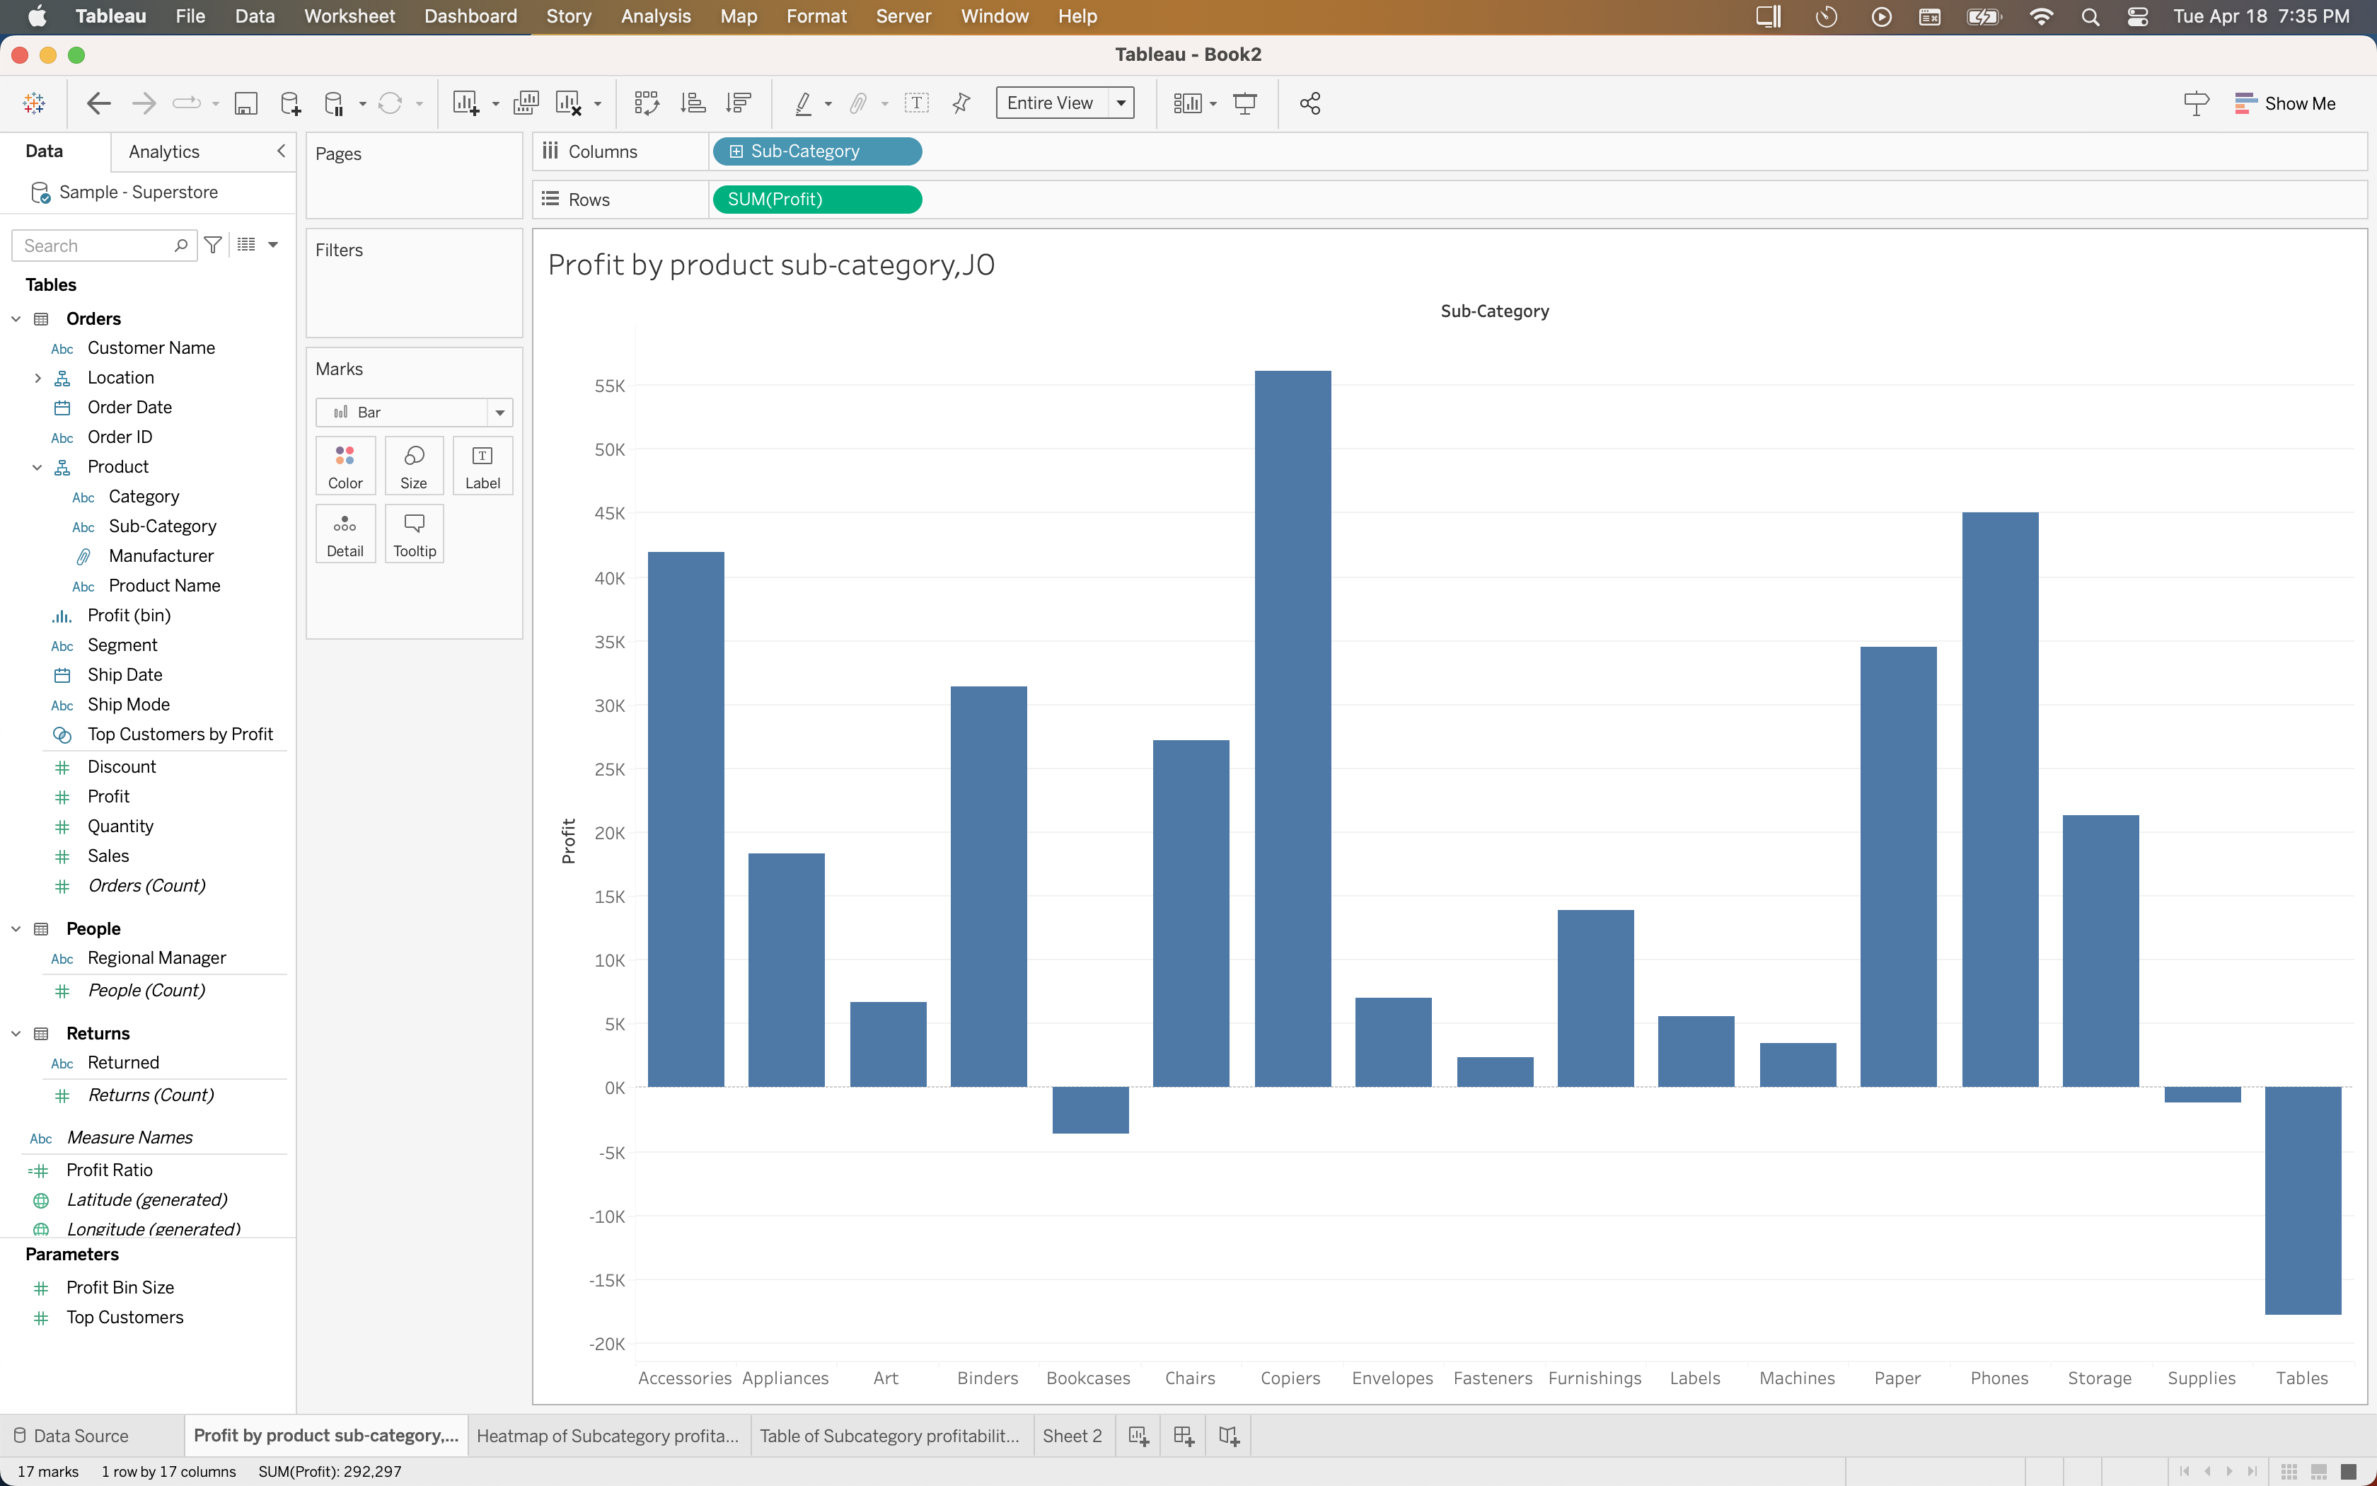

2. You wonder whether some of the sub-categories losing money have always done so. Create a heat map of the profit by sub-category over time. (Hint: the time variable in this data set is "Ship Date".) The heat map should use color, but not size, to represent the profit. Title it appropriately, including your initials in the title. Sort the heat map by most to least profitable in the last year that had complete data.

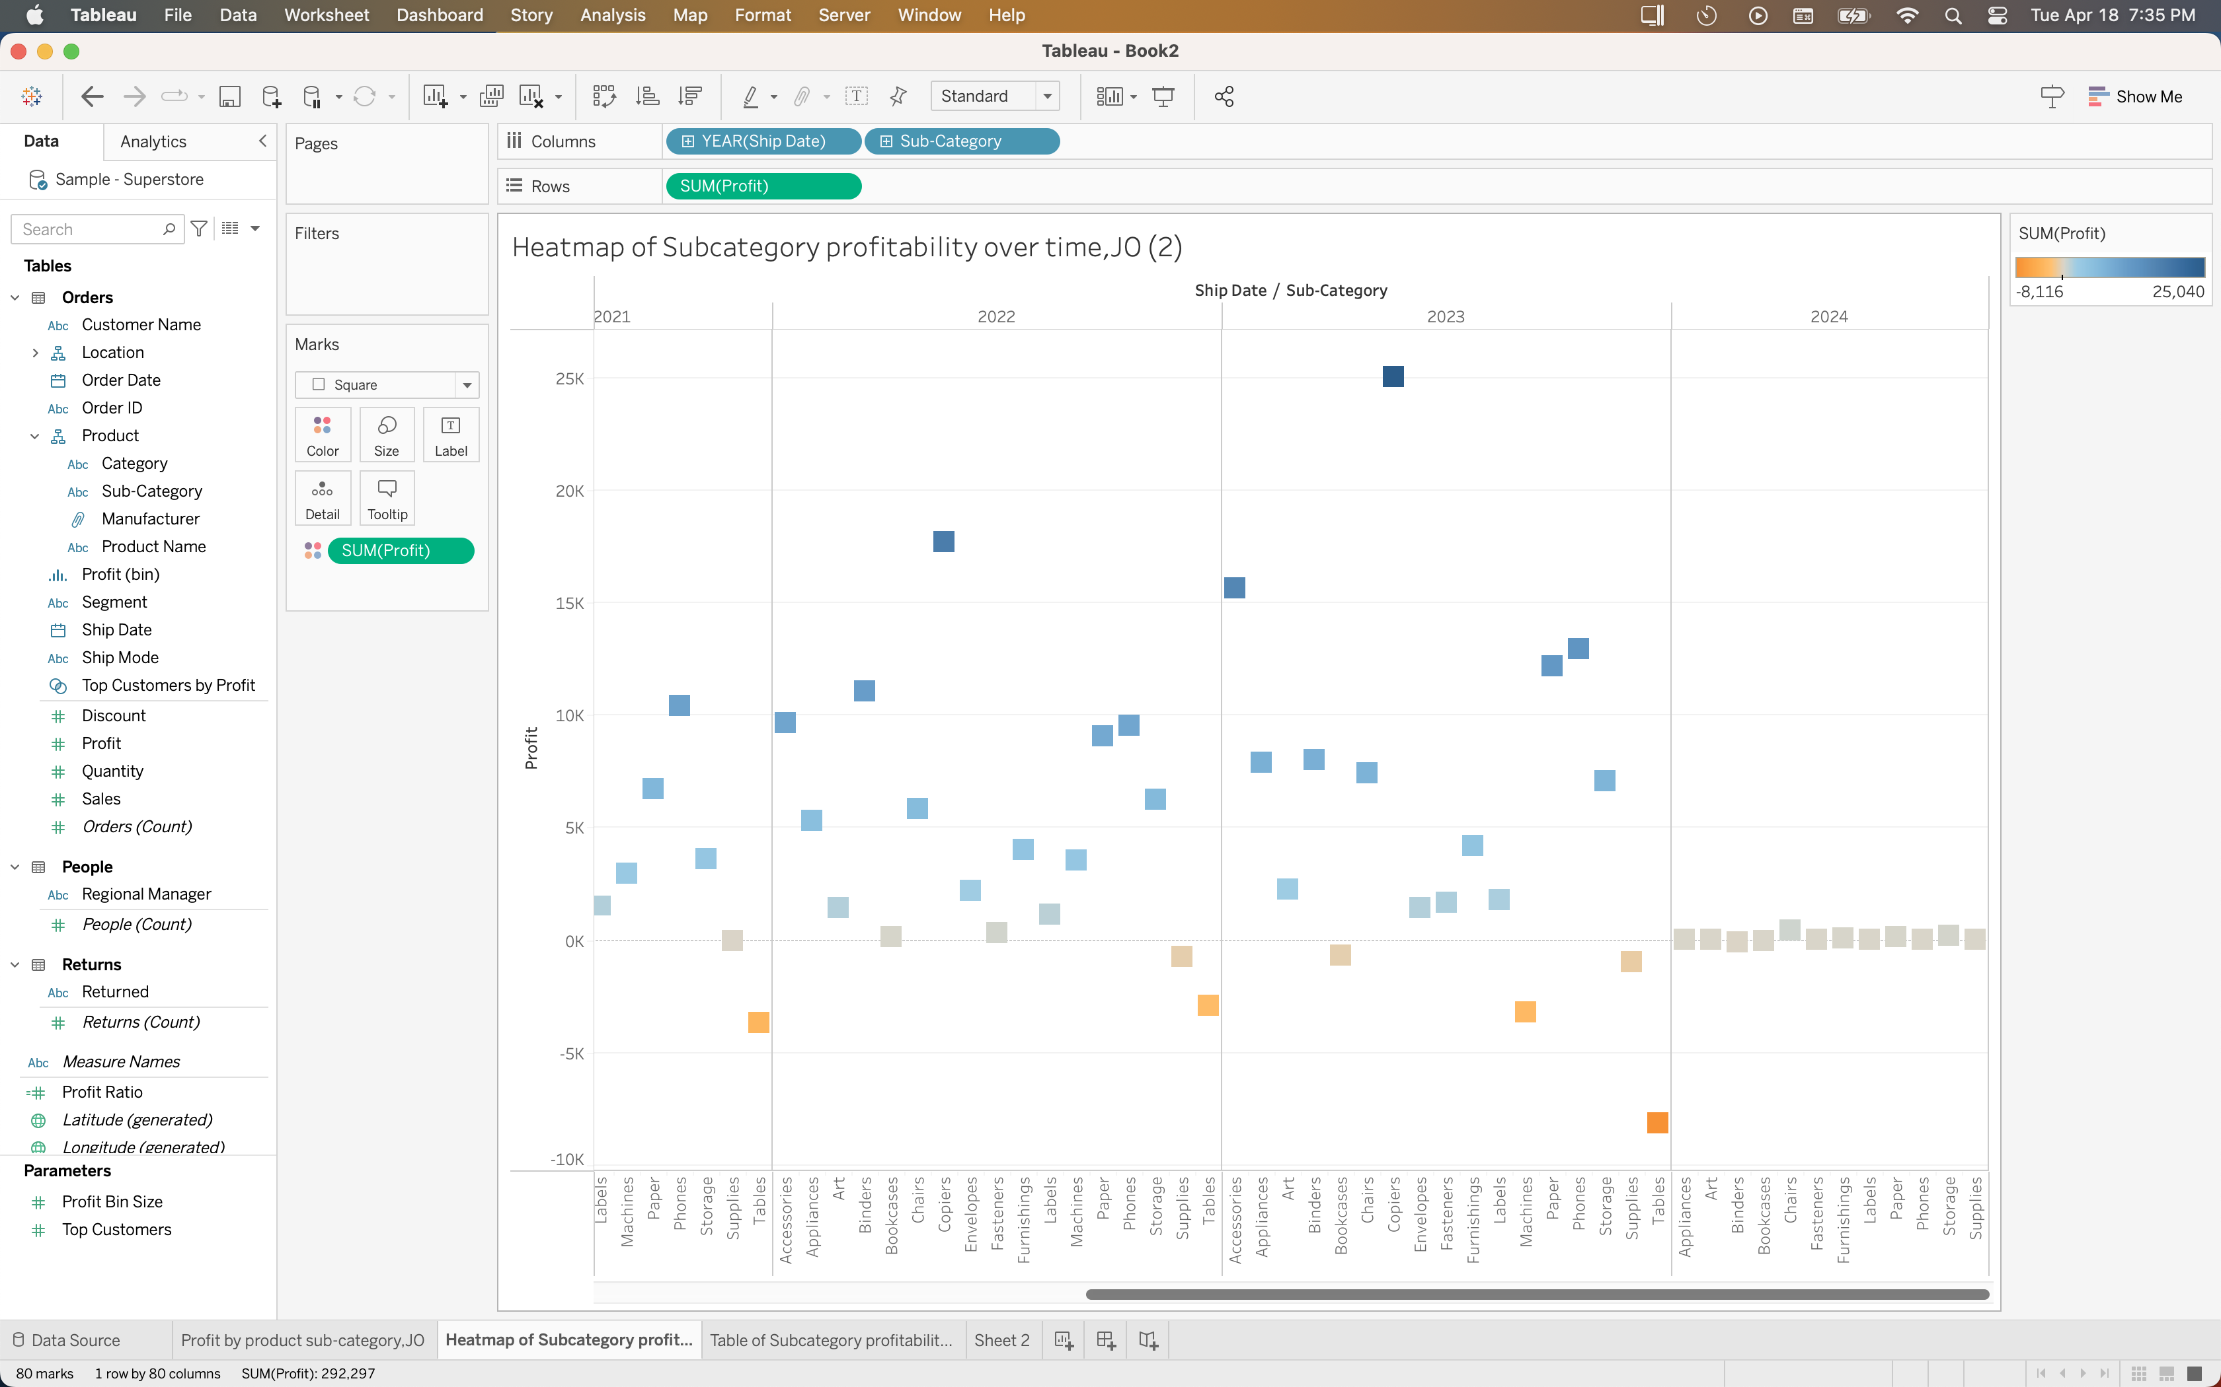

3.

Answer the following questions about the heat map:

A. Why was this the best color scheme for this use case?

Diverging was the best color scheme in this case because there are two poles of profitability. They are profit and no profit. Using a diverging color scheme enables the viewer to easily identify which category the product belongs to.

B. Was the color scheme automatically created in the heat map sequential or diverging?

The color scheme generated was diverging.

C. Why was it better to represent profit using color rather than size of the box?

The size of the box would cause a box to breach another subcategory’s space along the x-axis thus making it more confusing to decipher which subcategory the data point belongs to.

4. Create a table of profit by sub-category over time. Title it appropriately. Leave the sub-categories in alphabetical order to make look up easier for the viewer.

